

LAB REPORT

CSE416: Web Engineering Lab

|  |
| --- |
| 03 [Report Number] |

Topic: Web Development Experiments using HTML, CSS, and JavaScript

Submitted To

**ENGR. NISHAT SADAF LIRA**

Lecturer

Department of CSE, Daffodil International University

Submitted By

Student ID: 221-15-4698

Section: 61_J2

Student Name: **Hossain Md Jakaria**

Date of Lab Report Submission: 20th August, 2025

## **1. Objective**

The objectives of this lab session were to:

* Develop and style responsive web applications using HTML, CSS, and JavaScript.
* Implement interactive features such as navigation bars, product grids, animations, and game logic.
* Gain hands-on experience in **DOM manipulation, event handling, and responsive design techniques**.

## **2. Equipment and Software Used**

|  |  |  |
| --- | --- | --- |
| **Sl. No.** | **Equipment / Software** | **Description** |
| 1 | Laptop / PC | Used for coding, testing, and executing web applications. |
| 2 | Visual Studio Code | Code editor for writing HTML, CSS, and JavaScript. |
| 3 | Google Chrome | Browser used for viewing, debugging, and testing the projects. |
| 4 | HTML5, CSS3 & JavaScript | Programming languages for structure, styling, and interactivity. |
| 5 | Font Awesome | External library used for icons. |

## **3. Theory / Background**

In this lab, we created **two different projects** using **HTML, CSS, and JavaScript:**

1. **Responsive Shopping Webpage**
   * HTML structured the layout (navbar, banner, products, cart, footer).
   * CSS handled the design, hover effects, transitions, and responsive behavior.
   * JavaScript dynamically generated product cards, calculated discounts, and managed cart updates.
2. **Tic Tac Toe Game (Input-Based Version)**
   * HTML created a 3×3 grid board and input fields for both players.
   * CSS styled the grid, inputs, and game status messages.
   * JavaScript handled turn-taking, board updates, win/draw detection, and game resets.

## **4. Procedure**

### **Experiment 1: Responsive Shopping Webpage**

1. **Navbar:** Added shop title, account links, dropdowns, search bar, and cart icon.
2. **Banner:** Inserted a promotional section with a "Shop Now" button.
3. **Product Grid:** Created product cards with images, original price, discount, and hover effects.
4. **Cart Functionality:** Implemented a sliding side cart with dynamic item updates.
5. **Responsive Design:** Used Flexbox, Grid, and media queries for mobile/tablet compatibility.

### **Experiment 2: Tic Tac Toe Game**

1. **Board Layout:** Created a 3×3 grid with numbered cells (0–8).
2. **Input Section:** Added two input fields for Player 1 (X) and Player 2 (O).
3. **Game Logic:** Used JavaScript to check for valid moves, update board, and switch turns.
4. **Win/Draw Detection:** Implemented winning conditions and draw checking.
5. **Reset Function:** Provided a restart button to clear the board and reset the game.

## **5. Code Implementation**

### **HTML, CSS & JS** [[Full Code on GitHub]](https://github.com/Sadik881583/Web-Engineering/tree/main/Lab-05)

### **Experiment 1: Shopping Webpage**

* **index.html** → Defines navbar, banner, product grid, and footer.
* **style.css** → Styles webpage layout, hover effects, and responsive design.
* **script.js** → Handles product rendering, discount logic, and cart operations.

### **Experiment 2: Tic Tac Toe Game**

* **index.html** → Defines game board, input fields, and status messages.
* **style.css** → Styles grid cells, inputs, and reset button.
* **script.js** → Manages turn-taking, win/draw detection, and game reset functionality.

## **6. Output / Observations**

### **Experiment 1: Shopping Webpage**

* Navbar with search bar, account options, and animated cart icon.
* Banner section with background image and CTA button.
* Product section displaying items with hover zoom effect and discount calculation.
* Side cart updated dynamically with item quantities and prices.
* Layout automatically adapted to different screen sizes.

### 

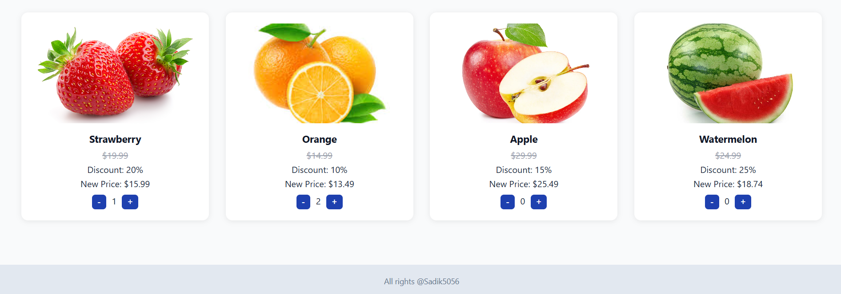

### **Experiment 2: Tic Tac Toe Game**

* 3×3 board with numbered cells.
* Players entered cell positions (0–8) through input fields.
* Game switched turns between Player X and Player O.
* Correctly detected wins, draws, and displayed game status.
* Reset button successfully cleared the game state.

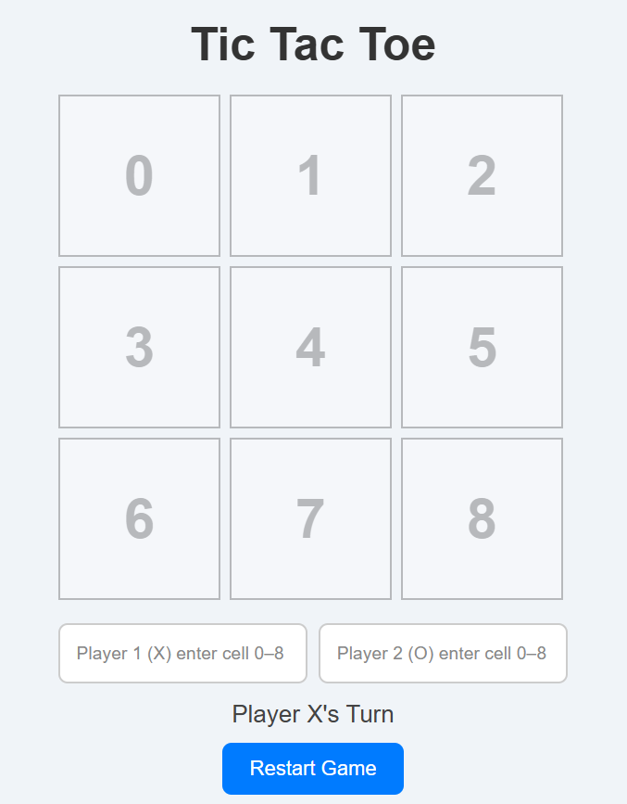 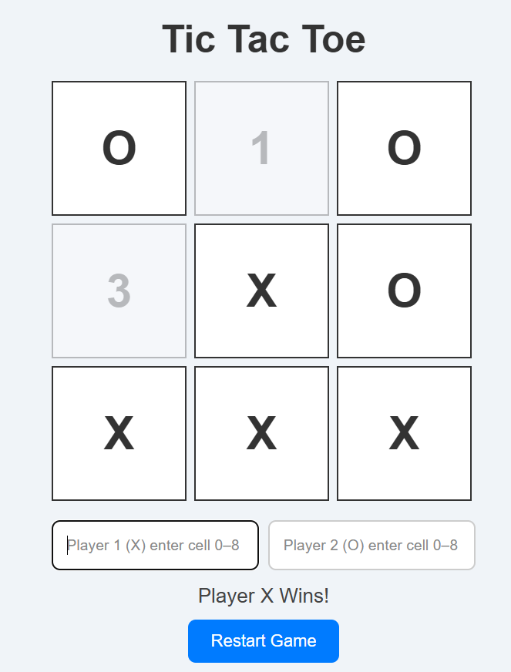 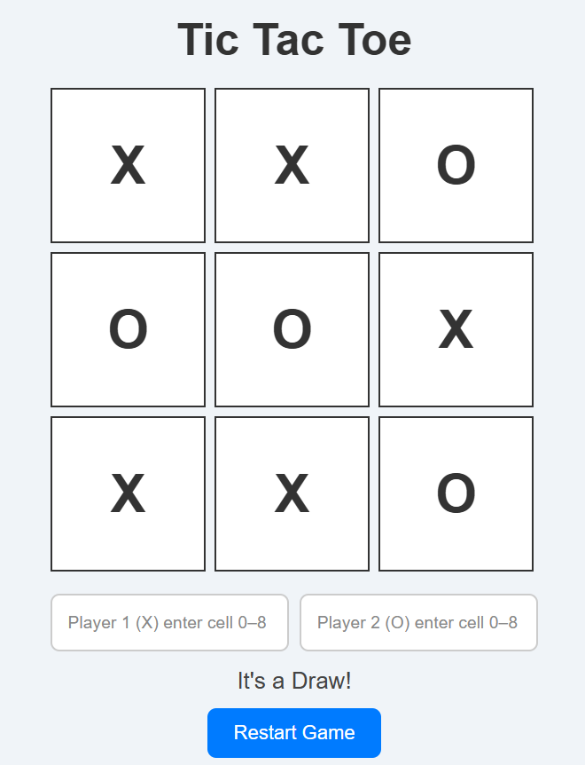

## **7. Result**

Both projects were successfully implemented:

* A **responsive shopping webpage** with functional cart and interactivity.
* An **input-based Tic Tac Toe game** with win/draw detection and reset functionality.

## **8. Conclusion**

This lab strengthened practical knowledge of **web technologies** by building two different applications.

* The **Shopping Webpage** improved skills in responsive design, dynamic content rendering, and UI styling.
* The **Tic Tac Toe Game** provided insights into handling user input, implementing game logic, and using event listeners effectively.

Together, these works demonstrated how **HTML (structure), CSS (design), and JavaScript (logic)** integrate to create functional, interactive, and user-friendly web applications.

## **9. References**

* MDN Web Docs – <https://developer.mozilla.org/en-US/docs/Web>
* W3Schools – [https://www.w3schools.com](https://www.w3schools.com/)
* Font Awesome – [https://fontawesome.com](https://fontawesome.com/)